Running Title: Temperature effects on switchgrass seed germination

Screening Switchgrass (Panicum virgatum L.) Genotypes for Temperature Tolerance via in vitro Seed Germination Assay

Ramdeo Seepaul, Bisoondat Macoon, K. Raja Reddy* and Brian Baldwin

R. Seepaul, K.R. Reddy, and B.S. Baldwin, Department of Plant and Soil Sciences, 117 Dorman Hall, Box 9555, Mississippi State University, Mississippi State, MS 39762; B. Macoon, Central Mississippi Research and Extension Center, 1320 Seven Springs Road
Raymond, MS 39154. Received September 2010. *Corresponding author (krreddy@pss.msstate.edu).
Abstract
Cardinal temperatures for plant processes have been used for thermotolerance screening of genotypes, geoclimatic adaptability determination and phenological prediction. Current simulation models for switchgrass (Panicum virgatum L.) utilize blanket cardinal temperatures across genotypes for both vegetative and reproductive processes although intra-specific variation exists among genotypes. An experiment was conducted to estimate the cardinal temperatures for seed germination of 14 diverse switchgrass genotypes and to classify genotypes for temperature tolerance. Stratified seeds of each genotype were germinated at seven constant temperatures from 15 to 45 °C and under a constant light intensity of 35 µmol m⁻² s⁻¹ for 12 h d⁻¹. Germination was recorded at 6-h interval in all treatments. Maximum seed germination (MSG) and germination rate (GR), estimated by fitting Sigmoidal function to germination-time series data, varied among genotypes. Quadratic and bilinear models best described the MSG and GR responses to temperature, respectively. The mean cardinal temperatures, T_{min}, T_{opt} and T_{max}, were 8.1, 26.6, and 45.1°C for MSG and 11.1, 33.1, and 46.0°C for GR, respectively. Cardinal temperatures for MSG and GR; however, varied significantly among switchgrass genotypes. Genotypes were classified as sensitive (‘Cave-in-rock’, ‘Dacotah’, ‘Expresso’, ‘Forestburg’, ‘Kanlow’, ‘Sunburst’, ‘Trailblazer’, and ‘Warrior’), intermediate (‘Alamo’, ‘Blackwell’, ‘Carthage’, ‘Shawnee’, and ‘Shelter’) and tolerant (‘Summer’) to high temperature based on cumulative temperature response index (CTRI) estimated by summing individual response indices estimated from the MSG and GR cardinal temperatures. Similarly, genotypes were also classified as sensitive (Alamo, Blackwell, Carthage, Dacotah, Shawnee, Shelter, and Summer), moderately sensitive (Cave-in-rock, Forestburg, Kanlow, Sunburst, and Warrior), moderately tolerant (Trailblazer) and tolerant (Expresso) to low temperatures. The cardinal temperature estimates would be useful to improve switchgrass models for field applications. Additionally, the identified cold- and heat-tolerant genotypes can be selected for niche environments and in switchgrass breeding programs to develop new genotypes for low and high temperature environments.

Key-words
Switchgrass; cardinal temperature; temperature tolerance; germination; genotype variability; response index; screening; genotype classification
Abbreviations: CTRI, cumulative temperature response index; GR, germination rate; ITRI, individual temperature response index; MSG, maximum seed germination; RMSE, root mean square error; TAR, temperature adaptability range.

The adoption of a feedstock species for a niche environment is favored on the species ability to grow and sustain under a wide range of growing conditions and their ability to produce high yields and quality biomass. From an agronomic perspective, the species should also be able to establish rapidly and uniformly under existing conditions to escape weed competition and late-season water unavailability (Hacisalihoglu, 2008). Establishment of warm-season feedstock grasses has been limited due to slow germination and low seedling vigor ( Hsu et al., 1984; Aiken and Springer, 1995), particularly in the first year after seeding, presenting a major problem in the improvement of existing stands, or in establishing new stands. Slight or moderate successes of native grasses establishment can be attributed to dormancy and delayed germination (Robocker et al., 1953). Seeding feedstock fields require knowledge of many parameters, including optimum temperature and moisture conditions for rapid germination and establishment (Fulbright, 1988; Hanson and Johnson, 2005).
Switchgrass (Panicum virgatum L.), a warm-season, native C₄ bunch grass species was identified as a potential and model lignocellulosic biofuel feedstock by the US Department of Energy’s Bioenergy Feedstock Development Program (McLaughlin and Walsh, 1998). It is a highly diverse species with significant genetic (Das et al., 2004) and phenotypic variation resulting from gene migration, random genetic drift, mutation, natural selection (Eberhart and Newell, 1959) combined with environmental variation due to latitude, altitude, soil type, and precipitation (Casler et al., 2007).
Temperature is a major environmental factor influencing seed germination capacity and rate and seedling vigor (Hsu et al., 1984). Temperature affects the maximum seed germination and germination rate through three distinct processes; its effect on seed deterioration (seed aging), dormancy loss, and on the germination process itself (Roberts, 1988). Extreme temperatures are the single most important factor delimiting the distribution, adaptability and yield potential of plants. High or low soil temperatures at sowing can reduce plant populations necessitating seed temperature tolerance for adequate crop establishment.
Determining temperature effects on seed germination using mathematical functions may be useful in evaluating germination characteristics or establishment potential among genotypes or species (Jordan and Haferkamp, 1989). Final seed germination percentage and germination rate are both considered sensitive indicators of seedling vigor (Larsen and Andreasen, 2004). Germination as a process, can be defined by three cardinal temperatures (T_{min}, T_{max,} and T_{opt}), which determine the range of temperatures over which germination can occur. Previous studies that reported the effects of temperature on switchgrass germination capacity and rate did not quantify the cardinal temperatures for a diverse population of switchgrass genotypes. Parrish and Fike (2005) reported that switchgrass germinates slowly when the temperature is below 15.5°C with maximum germination occurring within 3 d of imbibition at 29.5°C. Hsu et al. (1985) reported that the minimum temperature for switchgrass germination is 10.3°C and optimum temperature occurring between 25 and 30°C. Minimum temperatures are critical for accurate phenological predictions because small differences in temperatures can cause large differences in germination time. Current switchgrass models that simulate switchgrass phenology use blanket minimum temperatures that range from 10 - 12°C (McLaughlin et al., 1999; Heaton et al., 2004; Kiniry et al., 2005), although it is suspected that there is intraspecies variation.
The interest in switchgrass as a feedstock has fostered development and selection of a wide number of genotypes, which must be screened for various abiotic stress tolerances prior to release. Current screening methods are restricted to field performance and visual evaluations which may mask a genotype’s true potential or tolerance capacity due to unpredictable moisture and fluctuating temperatures in the field. Field screening for temperature tolerance is tedious, inconsistent, and seasonally limited; therefore the need for simple, rapid, and reliable technique to identify sources of tolerance and for evaluating a large number of breeding materials in controlled environments (Setimela et al., 2005). Screening for abiotic stress tolerance has been achieved using biochemical and physiological parameters at the germination, emergence, vegetative, and reproductive stages. Screening genotypes prior to field testing requires a controlled environment where temperature and moisture are monitored. In vitro seed-based screening can provide insights into genotypic environmental adaptability and tolerance capacity prior to field evaluations. Studies related to temperature tolerance screening in switchgrass; however, are limited in general and no reported studies using seed-based parameters have been found. Seed-based parameters, in particular, germination capacity and rate have been used successfully to screen several species and genotypes for various abiotic stress factors including drought (Bouslama and Schapaugh, Jr., 1984; Sadasivam et al., 2000), saline (Foolad and Lin, 1997; Misra and Dwivedi, 2004), flooding/water logging (Hou and Thseng, 1992; Sharma, 2008), chilling (Acharya et al., 1983; Tiryaki and Andrews, 2001), and heat tolerance (Emerson and Minor, 1979; Ellis et al., 1986) in other species. The temperature tolerance capacity of different genotypes may be determined by relative ranking using single value indices, percentiles and quartiles relative to control studies and cumulative indices, grouping based on statistical separation of means (Emerson and Minor, 1979; Koti et al., 2004; Salem et al., 2007) or quantitative relationships determined by principal component analysis (Kakani et al., 2002, 2005; Singh et al., 2008).
The objectives of this study were to (a) quantify the effects of temperature on seed germination capacity and rate, (b) determine the cardinal temperatures for seed germination capacity and rate, and (c) classify genotypes for temperature tolerance using cumulative temperature response index concept. The seed germination and temperature dependent functional algorithms developed from these data are a prerequisite for modeling the germination of a diverse switchgrass genotypes adapted to different climatic zones.
Materials and Methods

Seed Material

Seeds of 14 switchgrass genotypes, representative of northern and southern, upland and lowland ecotypes, were evaluated in this experiment (Table 1). For nine cultivars, seeds were collected from the plants grown during the 2006-2007 growing season at Mississippi State University, Mississippi State, MS, USA (33°28’N, 88°47’W). Seeds of Blackwell, Carthage, Cave-in-Rock, Shawnee, and Shelter were obtained from the Ernst Seed Company (Meadville, PA). Seeds were homogenously mixed and 100 seed per experimental unit for germination testing were counted by an electronic seed counter (Model 850-2; The Old Mill Company, Savage, MD).

Seed Quality Characteristics
Seed viability was determined by longitudinal dissection to reveal the embryo after 24 h imbibition using 0.1% (1g L⁻¹) triphenyl tetrazolium chloride stain. Partially or completely red or pink embryo was considered viable (ISTA, 1985). Approximately, 1 g of seed in triplicates was ground, homogenized, and sieved (40 mesh) and analyzed for nitrogen (N) and carbon (C) concentration with an automated CHN combustion analyzer (Perkin Elmer 2400; Perkin Elmer Corp., Norwalk, CT, Software: Eager 300 ver. 1.01). Individual seed C and N content were determined by multiplying the C and N concentration by the dry weight of the seed (C and N concentration × seed mass).

Seed Germination Testing
Moistened seeds were stratified at 5°C for 14 d according to Association of Official Seed Analysts (ASOA) rules with no humidity control from March to July 2009. Preliminary studies at low temperature (< 20°C) indicated that fungal infection can affect germination, prompting the use of Captan {cis-N-[(trichloromethyl)thio-4-cyclohexene-1,2-dicarboximide]} at 0.55 g ai kg⁻¹ seed as a drench prior to germination testing at all temperatures. Each genotype was replicated four times in a completely randomized design with 100 seed per replicate placed on a moistened single layer Whatman No. 1 filter paper (Whatman, Atlanta, GA) in a covered 90-cm sterilized disposable plastic Petri dish to minimize moisture loss. Petri dishes were vertically stacked at constant set temperature, 10 to 45°C with 5°C interval, and at constant light during an 12 h light period with a photon flux density of 35 ± 2.6 µmol m² s⁻¹, provided by cool white fluorescent lamps and 16 h dark for all genotypes and temperatures in a germination chamber (Fisher Scientific, Suwanee, GA). Petri dishes were monitored daily for moisture content of the filter paper and watered when necessary with distilled water.
Replicates for each genotype were completely randomized within the germination chamber for each temperature. To minimize the potential of small temperature changes within the chambers, the Petri dishes were rearranged every 6 h. Germinated seed were counted, recorded and discarded every 6 h. Counts were discontinued if no seed germinated for five consecutive days. A seed was considered germinated when the coleoptiles or coleorhizae was at least 2 mm long.

Curve Fitting Procedure and Data Analysis
Temperature and germination time-course data were fitted with a 3-parameter Sigmoidal function (Eq. [1]) using SigmaPlot 11 (Systat Software Inc., 2006). This function estimated a, the maximum cumulative seed germination percentage (germination capacity); b, the shape and steepness of the curve; and x0, time to reach 50% of maximum germination. The rate of development was derived by the reciprocal of time to 50% of maximum seed germination.
G = G_{max}/{1 + exp[- (x – x₅₀)/G_{rate}]} [1]
where G is the total seed germination percentage, G_{max} is the maximum cumulative seed germination percentage, x₅₀ is the time to 50% maximum seed germination, and G_{rate} is the slope of the curve.
Maximum seed germination and rate of development response to temperature were analyzed using linear and nonlinear regression techniques for all genotypes (Kakani et al., 2002). Based on the highest coefficient of determination (r²) value and the root mean square error (RMSE), the best curve fitting model was obtained. Accordingly, maximum seed germination was modeled using a quadratic function (r² = 0.88, RMSE = 5.2) while germination rate was modeled by a modified bilinear function (r² = 0.95, RMSE = 1.00). Quadratic and modified bilinear equations estimates for each replicate within each genotype were estimated using PROC NLIN of SAS (SAS Institute Inc., 2004) with a modified Newton Gauss iterative method. For the quadratic model (Eq. [2]), the three cardinal temperatures (T_{min}, T_{opt} and T_{max}), were estimated using Eq. [3] to [5].
MSG = a + bT – cT² [2]
T_{opt} = – b/ (2c) [3]
T_{min} = – b + (√b² – 4ac)/2c [4]
T_{max} = – b – (√b² – 4ac)/2c [5]
where MSG is the maximum seed germination, T_{opt}, T_{min}, and T_{max} are the optimum, minimum and maximum cardinal temperatures for seed germination, respectively, T is treatment temperature at which MSG was determined, and a, b, and c are genotype-specific constants generated using PROC GLM in SAS (SAS Institute Inc., 2004). For the modified bilinear model [6], T_{opt} was generated using SAS (SAS Institute Inc., 2004) while T_{min} and T_{max} were estimated using Eq. [7] and [8].
GR = a + b₁ (T – T_{opt}) + b₂ × ABS (T_{opt} – T) [6]
T_{min} = [a + (b₂ – b₁) × T_{opt}] / b₁ – b₂ [7]
T_{max} = [a – (b₂ + b₁) × T_{opt}] / b₁ + b₂ [8]
where GR is germination rate, T_{opt}, T_{min}, and T_{max} is the optimum, minimum and maximum cardinal temperatures for seed germination, respectively, T is the treatment temperature, and a, b_{1,} and b₂ are genotype-specific constants generated using PROC NLIN in SAS (SAS Institute Inc., 2004).

Cumulative Temperature Response Index (CTRI)
Switchgrass genotypes were classified into cold or heat tolerant groups based on the summation of seed individual temperature response index (ITRI) values following the protocol used by Salem et al. (2007) for pollen germination response to temperature. Accordingly, heat CTRI was calculated as the MSG and GR values for each of the cardinal temperatures (T_{min}, T_{opt}, and T_{max}) of a specific genotype, divided by the maximum value observed among all genotypes (Eq. [9]) while cold CTRI was determined by dividing the minimum value among all genotypes by the value of a specific genotype (Eq. [10]). Genotypes were classified based on CTRI of all parameters as cold-tolerant (> minimum CTRI + 4 standard deviations [SD]), moderately cold-tolerant (> minimum CTRI + 3 SD), moderately cold-sensitive (> minimum CTRI + 2 SD), and cold-sensitive (> minimum CTRI + 1 SD).
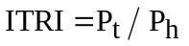
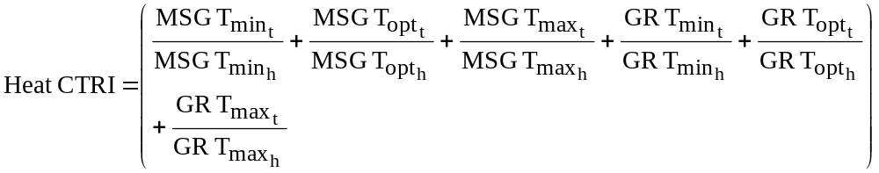 [9]

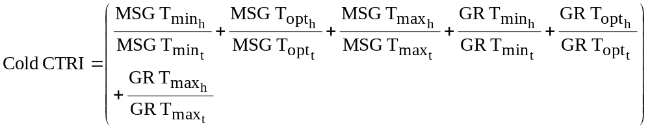 [10]

All cumulative germination data were arcsine transformed prior to analysis and back transformed for reporting. Replicated values of cardinal temperatures (T_{min}, T_{opt,}, and T_{max}), temperature adaptability range (TAR = T_{max} – T_{min}), and MSG were analyzed using the one-way ANOVA procedure (PROC GLM) in SAS (SAS Institute Inc., 2004) to determine the effect of temperature treatment on MSG and GR and their respective cardinal temperatures (T_{min}, T_{opt,}, and T_{max}). Cardinal temperatures for MSG and GR and seed biochemical parameter means were separated using Fishers protected least significant differences (LSD) at P = 0.05. Germination parameters (MSG and GR) were treated as dependent variables while temperature and time to germination as independent variables. Regression of test parameters was carried out using SigmaPlot 11.0. Also, the mean seed germination parameters response to temperature was tested based on lowland (Alamo, Expresso, Kanlow, and Tusca) or upland (Blackwell, Carthage, Cave-in-Rock, Dacotah, Forestburg, Shawnee, Shelter, Summer, Sunburst, and Trailblazer) ecotypes using Fishers protected least significant differences (LSD) at P = 0.05.
Results

Seed Quality Characteristics
Seed viability, seed weight, seed C and N content, and C: N ratios differed among genotypes (P < 0.05). Seed viability ranged from 73 (Kanlow) to 96% (Tusca) with a mean of 89% (Table 2). Individual seed weight ranged from 0.7 (Kanlow) to 1.89 mg seed⁻¹ (Trailblazer) with a mean of 1.39 mg seed⁻¹ (Table 2). Carbon content, on the other hand, ranged from 296 (Kanlow) to 823 µg seed⁻¹ (Trailblazer) with a mean of 594 µg seed⁻¹, while N content ranged from 16 (Kanlow) to 47 µg seed⁻¹ (Sunburst). Ecotypic classification of the genotypes reveals that seed C and N content and seed weight differed between upland and lowland genotypes (P < 0.05) (data not shown).

Germination Time Courses
The 3-parameter Sigmoidal function fitted the cumulative germination time course (mean r² = 0.98) of genotypes response to temperature efficiently, illustrating how the genotypes differed in their germination characteristics (Fig. 1). For clarity, only data and fitted lines for four genotypes, each representative of northern and southern upland (Cave-in-Rock and Shelter) and lowland (Alamo and Kanlow) ecotypes are presented. There was no germination at 10 or at 45°C in any of the genotypes tested.

Maximum Seed Germination Response to Temperature
Among the linear and nonlinear regression models tested, the quadratic function best described the response of MSG to temperature (mean r² = 0.93, RMSE = 5.2). For clarity, only data and fitted lines for four genotypes, each representative of northern and southern upland (Cave-in-Rock and Shelter) and lowland (Alamo and Kanlow) genotypes are presented (Fig. 2). Maximum seed germination varied (P < 0.001) among genotypes with a mean of 73% and ranged from 41 (Alamo) to 93% (Expresso). Cardinal temperatures (T_{min}, T_{opt,} and T_{max}) for MSG also differed among the genotypes (P < 0.001). The T_{min} values ranged from 3.69 (Expresso) to 12.83°C (Summer) with a mean of 8.08°C. The T_{opt} was 26.58°C; however, there was variation among the genotypes (P < 0.001). Summer recorded the highest T_{opt} (28.56°C) while Tusca showed the lowest (24.04°C). The T_{max} ranged from 41.81(Tusca) to 47.07°C (Expresso) with a mean of 45.07°C (Table 3). The TAR for MSG ranged from 43.38 (Expresso) to 31.37°C (Summer) with a mean of 37°C for all genotypes.
Grouping genotypes based on upland and lowland ecotype revealed no differences (P > 0.05) for MSG, TAR, T_{min}, and T_{max}; however, T_{opt} for MSG was different (P = 0.0471, LSD = 1.53) with mean of 27.02 and 25.47°C for upland and lowland ecotypes, respectively. Maximum seed germination for both upland and lowland ecotypes also varied (>10%) (Data not shown). Cardinal temperature variation was small between ecotypes (<4%). Maximum seed germination T_{min} was more variable than T_{opt} and T_{max} for both upland and lowland ecotypes. On average, MSG cardinal temperatures were 10 and 6% more variable than germination rate cardinal temperatures for upland and lowland ecotypes, respectively.

Germination Rate Response to Temperature
The modified bilinear equation best described the relationship between GR and temperature (mean r² = 0.95, RMSE = 1.0) among the linear and non-linear models tested. Cardinal temperatures for GR differed among genotypes (P < 0.05) (Table 4). For clarity, only data and predictor lines of four genotypes are presented in Fig. 3. The T_{min} ranged from 9.09 (Dacotah) to 12.92°C (Shelter) with a mean of 11.13°C. A mean of 33.12°C was estimated for T_{opt} which ranged from 29.55 (Shelter) to 35.73°C (Tusca). Highest T_{max} was recorded in Shelter (48.15°C), while the lowest T_{max} (45.0°C) was observed in Kanlow. The TAR ranged from 32.92 (Blackwell) to 36.18°C (Dacotah) with a mean of 34.88°C (Table 4). Ecotypic classification of genotypes indicate that TAR, T_{min}, and T_{max} did not differ, but T_{opt} was different (P < 0.05) with a mean of 32.37 and 34.98°C for upland and lowland ecotypes, respectively (P = 0.0477; LSD = 2.57). Cardinal temperatures variation was small between ecotypes (< 4%) with germination rate T_{min} being more variable than T_{opt} and T_{max} for both upland and lowland ecotypes (Table 4).

Genotype Classification Using Cumulative Temperature Response Index (CTRI)
Six parameters (T_{min}, T_{opt}, and T_{max} for both MSG and GR) were used for both heat- and cold-tolerance classification based on CTRI. Each parameter contributed differently based on its relation to the minimum or maximum value for that parameter across the genotypes. Using 1 standard deviation permitted the classification of heat-CTRI values (which ranged from 4.83 to 6.05) into three groups [heat-sensitive (4.83 – 5.43); intermediate (5.44 – 5.74), and heat-tolerant (5.73 – 6.05)]. Summer was identified as the most heat-tolerant genotype while Cave-in-Rock, Dacotah, Expresso, Forestburg, Kanlow, Sunburst, Trailblazer, and Tusca as heat-sensitive genotypes (Table 5).
Using the same parameters used for heat tolerance, the genotypes were similarly classified for cold-tolerance (Table 5). Cold-CTRI values, which ranged from 4.74 to 6.21, allowed grouping of genotypes into four tolerance categories [cold sensitive (4.74 – 5.03); moderately cold sensitive (5.04 – 5.32), moderately cold tolerant (5.33 – 5.62), and cold tolerant (5.63 – 6.21)]. Expresso had the highest cold-CTRI (5.64), and therefore considered as most cold-tolerant genotype, while the Summer had the highest cold-CTRI (5.78) and was classified as cold-susceptible genotype (Table 5).

Parameter Relationships
No significant correlation was found between maximum seed germination T_{min} and T_{max} and T_{opt} and T_{max} (P > 0.05); however, a positive linear correlation existed between T_{min} and T_{opt} (r² = 0.81, P < 0.0001). As T_{min} increased among the genotypes, T_{max} generally increased (r² = 0.56, P < 0.0021). An inverse relationship was found between T_{min} and T_{opt} (r² = 0.58, P < 0.0014) as well as T_{opt} and T_{max} (r² = 0.88, P < 0.0001). The correlation between MSG and GR cardinal temperatures varied, but a weak positive correlation was found between MSG and GR T_{min} (r² = 0.39, P = 0.0163), while a weak negative correlation was found between MSG and GR T_{opt} (r² = 0.46, P = 0.0071).
Seed quality parameters (C and N content and seed weight) did not correlate with cardinal temperatures of both MSG and GR (P > 0.05). However, MSG was correlated with seed C (r² = 0.29, P = 0.0469) and seed N (r² = 0.57, P = 0.0018) content and seed weight (r² = 0.26, P = 0.0623).
Discussion

Seed germination is a complex physiological process modulated by internal and external factors and their interactions. Similar to other growth and developmental processes, temperature influences seed dormancy, germination capacity and rate, and seedling emergence. To our knowledge, this is the first study to evaluate the influence of temperature effects on seed germination characteristics of diverse switchgrass genotypes. The resulting data provided functional algorithms for modeling and segregating genotypes for cold- and heat-tolerance based on seed-based parameters.
Optimal temperatures for MSG and GR differed among the genotypes with MSG optimum occurring over a range and GR having a sharply defined optimum. Relative to MSG, GR consistently had higher T_{min}, T_{opt},, and T_{max} values, even though the temperature adaptability range (TAR, T_{min}-T_{max}) among MSG and GR cardinal temperatures was small (< 6.18°C) with the exception of T_{min} of MSG, which ranged from 3.69 to 12.83°C. This is consistent with Roberts (1988) findings that many species typically have higher optimum temperatures for GR than for MSG percentage. Germination rate is reported to be more temperature sensitive than final germination percentage in Setaria lutescens and Amaranthus retroflexus (Schimpf et al., 1977) similar to our finding in switchgrass genotypes.

Seed Quality Characteristics
The influence of temperature on MSG has been quantified; however, these responses may be applicable to one seed population because of experiment-specific conditions (Ellis et al., 1987). Maximum seed germination is reportedly affected by seed quality (Ellis et al., 1987), seed maturation environment (Fenner, 2008; Orozco-Segovia et al., 1993; Sharif-Zadeh and Murdoch, 2007) and time from harvest to seeding (Shaidaee et al., 1969; Jensen and Boe, 1991); hence limiting the utility of MSG as a screening tool. Ellis et al. (1987) contended that the same criticism can be made for GR responses to temperature; however, cardinal temperatures (T_{min} and T_{opt}) have been reported to be unchanged by temperature and therefore are better parameters to evaluate the dispersion of responses across genotypes. Ellis et al. (1987) found no variation among T_{min} for three seedlots of onion (Allium cepa L.) differing in viability, suggesting that germination minimum temperature is a genotypic characteristic unaffected by seed quality.

Maximum Seed Germination
All switchgrass genotypes tested exhibited a quadratic response to temperature (r² = 0.93), similar to indiangrass (Fulbright, 1988), another native warm-season species. Mean MSG (73%) in the current study is similar to the 77-78% reported for similar genotypes (Springer, 1995; Hanson and Johnson, 2005; Hacisalihoglu, 2008). With the exception of Expresso, which has been selected for increased precocious germination, MSG of the other two lowland genotypes (Alamo and Kanlow) were less than 55%.
The optimum temperature for switchgrass MSG in the current study varied between 24.04 and 28.56°C among the genotypes, which is within the range of values reported in other warm-season grasses; 20 – 30°C for Cane beardgrass [Bothriochloa barbinodis (Lag.) Herter], sideoats grama [Bouteloua curtipendula (Michx.) Torr.], and tanglehead [Heteropogon contortus (L.) P. Beauv. ex Roem. & Schult.] (Roundy and Biedenbender, 1996) and 16.5 – 27°C for Indiangrass (Sabo and Forest, 1979). Maximum seed germination minimum temperature averaged 8.08°C and ranged from 3.69 to 12.83°C, which is similar to T_{min} of other warm-season grasses reported by Madakadze et al. (2001); 5.5 - 10.9°C for switchgrass, 7.3 - 8.7°C for big bluestem (Andropogon gerardii Vitman), 7.5 - 9.6°C for Indiangrass, and 4.5 - 7.9°C for prairie sandreed (Calamovilfa longifolia (Hook.) Scribn.).

Germination Rate
Thermal response of switchgrass seed germination is consistent with thermal response patterns of a number of other physiological processes (Probert, 2000). At suboptimal temperatures (T_{min} to T_{opt}), germination rate (reciprocal time to 50% germination) generally increases linearly with temperature, but decreases linearly with temperature at supra-optimal temperatures (T_{opt} to T_{max}). This characteristic thermal response is similar to germination rate of chickpea (Cicer arietinum L.; Covell et al., 1986; Ellis et al., 1986), lentil (Lens culinaris Medic.) and soybean [Glycine max (L.) Merr.]; Covell et al., 1986), pearl millet (Pennisetum glaucum (L.) R. Br.; Garcia-Huidobro et al., 1982), sorghum [Sorghum bicolor (L.) Moench.; Benech-Arnold et al., 1990), and cool season weeds (Hardegree, 2006). A decline in germination rate with decreasing temperature is partly associated with an observed decline in the imbibition rate observed with a reduction in temperature (Lopez et al., 2000). Germination rate response to temperature was described previously by two linear equations; the first describing the positive linear relationship between the minimum and optimum temperatures and the second describing the negative linear relationship between optimum and maximum temperature (Covell et al., 1986; Ellis et al., 1986). In this study, GR was modeled using a single modified bilinear equation, which was previously used by several studies (Kakani et al., 2002, 2005; Reddy and Kakani, 2007; Salem et al., 2007; Singh et al., 2008) to quantify pollen germination and pollen tube growth responses to temperature. Analogous to pollen, seeds are considered independent functional units that are responsive to temperature changes.
Even though MSG percentage is the most important parameter determining commercial value of seedlots, GR influences the uniformity and rapidity of emergence in nurseries (El-Kassaby et al., 2008). Germination rates are most rapid at optimum temperature ranging from 29.5 to 35.6°C.
The variability in quantitative characteristics of rate of germination (T_{min}, T_{opt}, and T_{max} and TAR) among the genotypes may be attributed to genetic variability rather than seed quality. Seed quality characteristics did not correlate with MSG or GR cardinal temperatures; however, N content of seeds affected MSG suggesting cardinal temperatures are insensitive to seed quality characteristics tested while MSG is affected by seedlot quality.

Cardinal Temperatures
Biological processes are typically characterized by cardinal temperatures describing the range of temperature over which a process can occur. The effect of temperature on seed germination can be expressed in terms of cardinal temperatures, that is, T_{min}, T_{opt}, and T_{max} at which germination will occur (Copeland and McDonald, 2001). Cardinal temperatures may be used to describe the range of adaptation of a species.
Though switchgrass is reported to be the most temperature specific of the warm-season grasses (Hsu et al., 1985), there exists significant intra-specific differences in cardinal temperatures that may be related to the different areas of origin or adaptation ( Madakadze et al., 2001; Casler and Boe, 2003). The genotypes Cave-in-Rock, Dacotah, Forestburg, Shawnee, Shelter, Summer, Sunburst, and Trailblazer are from the more cooler northern regions where average minimum temperatures range from –23.3 to –17.8°C , while Alamo, Blackwell, Expresso, Kanlow, and Tusca are from the more warmer growing regions with average minimum temperatures ranging from –17.8 to 4.4°C. Cardinal temperature coefficients can be directly compared for screening germplasm (Hardegree, 2006). The cardinal temperatures derived for both MSG and GR can be used in evaluation of potential regions for introduction of switchgrass and also aid in on-farm operational practices such as appropriate sowing dates when soil temperature would be conducive to optimum germination and emergence and ultimately optimum stand establishment and crop performance. Genotypes with lower T_{min} values can be subjected to early-season sowing because of their inherent capacity to germinate in cooler temperatures. The variability of cardinal temperatures both for MSG and GR indicates broad latitudinal adaptation across the various plant hardiness zones of the USA (Casler et al., 2004).
The cardinal temperatures derived for GR may be comparable with subsequent developmental stages of switchgrass ontogeny (morphological development). Kiniry et al. (2005) assumed a base temperature of 12°C for all growth stages of switchgrass in the ALMANAC model; however, the results in this study suggest that cardinal temperatures are genotype-specific and may be process-specific as well. Therefore, the derived cardinal temperatures in this study may be used to refine model algorithms for on-farm application and policy assessments.

Temperature Tolerance Classification
Temperature tolerance refers to the ability of an organism to cope with excessively high or low temperatures. Direct selection under field conditions is generally difficult because uncontrollable environmental factors affect the precision and repeatability of such trials. Stress tolerance is a developmentally regulated, stage-specific phenomenon; hence species may show different sensitivity to stress at different developmental stages. All stages through a plant’s ontogeny are sensitive to temperature; therefore, screening for tolerance should be conducted at the most sensitive stage. Seed germination is temperature dependent and can be used to screen for temperature tolerance. In vitro assays are not subjected to uncontrollable biotic and abiotic stress factors marring true tolerance potential. In the field, genotypes with high minimum temperature would experience little germination in early spring when temperatures would frequently drop below the T_{min} level.
In the current study, the successful use of CTRI, based on the summation of individual temperature response indices and then separated by standard deviation based on the number of classes of interest, confirms that seed-based parameters derived from in vitro seed germination assay can be used for genotype temperature tolerance classification. Genotype variability associated with temperature tolerance was demonstrated in this study. Alamo, Blackwell, Carthage, Dacotah, Shawnee, Shelter, and Summer were classified as cold-sensitive while Expresso was classified as cold-tolerant. Conversely, Cave-in-Rock, Dacotah, Expresso, Forestburg, Kanlow, Sunburst, Trailblazer, and Tusca were determined to be heat-sensitive and Summer as heat-tolerant. Since basal temperature tolerance is a function of genetics and acquired temperature tolerance is latitude and temperature-induced, corroborating seed-based temperature tolerance with vegetative or other reproductive responses will validate the use of seed-based parameters as a screening tool. This information is lacking in the literature with respect to screening temperature tolerance of diverse switchgrass genotypes, even though several studies link intraspecific differences in germination to geographical and ecological areas of distribution or origin (Orozco-Segovia et al., 1996). The classification method tested suggests that CTRI for heat- and cold-tolerance are inversely related (r² = 0.64, P = 0.0006), indicating that heat- and cold-tolerance may be unique and independent traits and may not occur simultaneously within a single genotype (Fig. 4). Variability among genotypes for heat- and cold-tolerance suggests that selection or breeding among genotypes is a viable objective.
Switchgrass adaptation to a specific ecoclimatic and edaphic region is determined by the growth rate, photoperiodism, heat tolerance, and cold or freezing tolerance of a specific genotype (Casler et al., 2007). Ecotype classification in this study did not necessarily confer the temperature tolerance characteristic of a specific ecotype. For example, Alamo, a lowland genotype, was classified as intermediately heat-tolerant while Summer, an upland genotype was classified as heat-tolerant using seed-based parameters. Genotype temperature tolerance is determined not only by ecotypic classification, but also latitude of origin, photoperiodism and genetics. Being photoperiod sensitive (Moser and Vogel, 1995), switchgrass morphological development is determined primarily by its response to photoperiod (Mitchell and Moser, 2000). Since ecotypic classification are more related to photoperiod responsiveness than temperature, the small or little variation observed between upland and lowland ecotypes for seed germination characteristics may be as result of ecotypic temperature insensitivity.
Since tolerance mechanisms are developmentally regulated, it is prudent to validate controlled in vitro seed germination assay with field performance tests. In the current study, GR and MSG were evaluated as estimators of temperature tolerance using 14 diverse genotypes. Using similar techniques, Tiryaki and Andrews (2001) screened 12 genotypes of sorghum for cold tolerance in controlled in vitro germination studies and found that GR was strongly correlated with rate of emergence under field conditions, confirming that screening using parameters based on in vitro studies is a rapid and reliable method for handling large number of genotypes before evaluation in the field. The current study quantified the relation between GR and temperature, highlighting genotypic differences. It is necessary in future work, therefore, to determine whether in vitro seed germination assay has potential in selection and screening procedures in breeding programs (Covell et al., 1986).

SUMAARY and Conclusions
The current study quantified the effects of temperature on seed germination rate and capacity of 14 diverse switchgrass genotypes and determined the cardinal temperatures for MSG and GR. Genotypic variability for MSG, GR, their respective cardinal temperatures, and TAR were found to exist among the switchgrass genotypes tested. Mean minimum temperatures for MSG and GR were 8.08 and 11.1°C, respectively, while optimum temperatures were 26.6 and 33.1°C, respectively. The cumulative temperature response index method used in the current study identified both heat and cold tolerant genotypes and demonstrated that variability existed among genotypes and ecotypes. The cardinal temperature estimates would be useful to improve switchgrass models for field applications. Additionally, the identified cold- and heat-tolerant genotypes can be selected for niche environments and in switchgrass breeding programs to develop new genotypes for cold and hot environments.

Acknowledgements
This research was funded in part by the Department of Energy through Sustainable Energy Center, Mississippi State University, Mississippi State, MS, the USDA-UV-B Monitoring and Research Program, and the USDA-ARS 58-6402-7-241. This article has been approved for publication as Journal Article No. ------- of the Mississippi Agricultural and Forestry Experiment Station, Mississippi State University.
References
Acharya, S.N., J. Dueck, and R.K. Downey, 1983. Selection and heritability studies on canola/rapeseed for low temperature germination. Can. J. Plant Sci. 63:377-384.
Aiken, G.E., and T.L. Springer. 1995. Seed size distribution, germination, and emergence of six switchgrass cultivars. J. Range Manage. 48:455-458.
AOSA. 1991. Rules for testing seeds. J. Seed Technol. 12:1-122.
Barker, R.E., R.J. Haas, E.T. Jacobson, and J.D. Berdahl. 1988. Registration of 'Forestburg' switchgrass. Crop Sci. 28:192-193.
Barker, R.E., R.J. Haas, J.D. Berdahl, and E.T. Jacobson. 1990. Registration of 'Dacotah' switchgrass. Crop Sci. 30:1158-1158.
Benech-Arnold, R.L., C.M. Ghersa, R.A. Sanchez, and P. Insausti. 1990. Temperature effects on dormancy release and germination rate in Sorghum halepense (L.) Pers. seeds: a quantitative analysis. Weed Res. 30:81 - 89.
Boe, A., and J.G. Ross. 1998. Registration of 'Sunburst' switchgrass. Crop Sci. 38:540-540.
Bouslama, M., and W.T. Schapaugh, Jr. 1984. Stress tolerance in soybeans. I. Evaluation of three screening techniques for heat and drought tolerance. Crop Sci. 24:933-933.
Casler, M.D., and A.R. Boe. 2003. Cultivar x environment interactions in switchgrass. Crop Sci. 43:2226-2233.
Casler, M.D., K.P. Vogel, C.M. Taliaferro, and R.L. Wynia. 2004. Latitudinal adaptation of switchgrass populations. Crop Sci. 44:293-303.
Casler, M.D., K.P. Vogel, C.M. Taliaferro, N.J. Ehlke, J.D. Berdahl, E.C. Brummer, R.L. Kallenbach, C.P. West, and R.B. Mitchell. 2007. Latitudinal and longitudinal adaptation of switchgrass populations. Crop Sci. 47:2249-2260. DOI: 10.2135/cropsci2006.12.0780.
Copeland, L., and M.B. McDonald. 2001. Principles of Seed Science and Technology. 4th ed. Springer, Norwell, MA.
Covell, S., R.H. Ellis, E.H. Roberts, and R.J. Summerfield. 1986. The influence of temperature on seed germination rate in grain legumes. I. A comparison of chickpea, lentil, soyabean and cowpea at constant temperatures. J. Exp. Bot. 37:705-715.
Das M.K., R.G. Fuentes, and C.M. Taliaferro. 2004. Genetic variability and trait relationships in switchgrass. Crop Sci. 44:443-448.
Eberhart S.A., and L.C. Newell. 1959. Variation in domestic collections of switchgrass, Panicum virgatum L. Agron. J. 51:613-616.
El-Kassaby Y.A., I. Moss, D. Kolotelo, and M. Stoehr. 2008. Seed germination: Mathematical representation and parameters extraction. For. Sci. 54:220-227.
Ellis, R.H., G. Simon, and S. Covell. 1987. The influence of temperature on seed germination rate in grain legumes III. A comparison of five faba bean genotypes at constant temperatures using a new screening method. J. Exp. Bot. 38:1033-1043.
Ellis, R.H., S. Covell, E.H. Roberts, and R.J. Summerfield. 1986. The influence of temperature on seed germination rate in grain legumes II. Intraspecific variation in chickpea (Cicer arietinum L.) at constant temperatures. J. Exp. Bot. 37:1503-1515.
Emerson, B.N., and H.C. Minor. 1979. Response of soybeans to high temperature during germination. Crop Sci. 19:553-553.
Fenner, M. 2008. The effects of the parent environment on seed germinability. Seed Sci. Res. 1:75-84.
Foolad, M.R., and G.Y. Lin. 1997. Genetic potential for salt tolerance during germination in Lycopersicon species. HortScience 32:296-300.
Fulbright, T.E. 1988. Effects of temperature, water potential, and sodium chloride on Indiangrass germination. J. Range Manage. 41:207-210.
Garcia-Huidobro, J., J.L. Monteith, and G.R. Squire. 1982. Time, Temperature and Germination of Pearl Millet (Pennisetum typhoides S. & H.) I. Constant temperature. J. Exp. Bot. 33:288-296.
Hacisalihoglu, G. 2008. Responses of three switchgrass (Panicum virgatum L.) cultivars to seed priming and differential aging conditions. Acta Agri. Scand. B - SP 58:280-284.
Hanson, J.D., and H.A. Johnson. 2005. Germination of switchgrass under various temperature and pH regimes. Seed Technol. 27:203-210.
Hardegree, S.P. 2006. Predicting germination response to temperature. I. Cardinal-temperature models and subpopulation-specific regression. Ann. Bot. 97:1115-1125.
Heaton, E., T. Voigt, and S.P. Long. 2004. A quantitative review comparing the yields of two candidate C₄ perennial biomass crops in relation to nitrogen, temperature and water. Biomass Bioenergy 27:21-30.
Hou F.F., and F.S. Thseng. 1992. Studies on the screening technique for pre-germination flooding tolerance in soybean. Jpn. J. Crop Sci. 61:447-453.
Hsu, F.H., C.J. Nelson, and W.S. Chow. 1984. A mathematical model to utilize the logistic function in germination and seedling growth. J. Exp. Bot. 35:1629-1640.
Hsu, F.H., C.J. Nelson, and A.G. Matches. 1985. Temperature effects on germination of perennial warm-season forage grasses. Crop Sci. 25:215-215.
ISTA. 1985. International Rules for Seed Testing. Annexe to chapter 6. Biochemical test for viability. Seed Sci. and Technol. 13:464-483.
Jensen, N.K., and A. Boe. 1991. Germination of mechanically scarified neoteric switchgrass seed. J. Range Manage. 44:299-301.
Jordan, G.L., and M.R. Haferkamp. 1989. Temperature responses and calculated heat units for germination of several range grasses and shrubs. J. Range Manage. 42:41-45.
Kakani, V.G., P.V.V. Prasad, P.Q. Craufurd, and T.R. Wheeler. 2002. Response of in vitro pollen germination and pollen tube growth of groundnut (Arachis hypogaea L.) genotypes to temperature. Plant Cell Environ. 25:1651-1661.
Kakani, V.G., K.R. Reddy, S. Koti, T.P. Wallace, P.V.V. Prasad, V.R. Reddy, and D. Zhao. 2005. Differences in in vitro pollen germination and pollen tube growth of cotton cultivars in response to high temperature. Ann. Bot. 96:59-67.
Kiniry, J.R., K.A. Cassida, M.A. Hussey, J.P. Muir, W.R. Ocumpaugh, J.C. Read, R.L. Reed, M.A. Sanderson, B.C. Venuto, and J.R. Williams. 2005. Switchgrass simulation by the ALMANAC model at diverse sites in the southern US. Biomass Bioenergy 29:419-425.
Koti, S., K.R. Reddy, V.G. Kakani, D. Zhao, and V.R. Reddy. 2004. Soybean (Glycine max) pollen germination characteristics, flower and pollen morphology in response to enhanced ultraviolet-B radiation. Ann. Bot. 94:855.
Larsen, S.U., and C. Andreasen. 2004. Light and heavy turfgrass seeds differ in germination percentage and mean germination thermal time. Crop Sci. 44:1710-1720.
Lopez, M., J.M. Humara, A. Casares, and J. Majada. 2000. The effect of temperature and water stress on laboratory germination of Eucalyptus globulus Labill. seeds of different sizes. Ann. For. Sci. 57:245-250.
Madakadze, I.C., B. Prithiviraj, K.A. Stewart, P.R. Peterson , B.E. Coulman, and D.L. Smith. 2001. Variation in base temperatures for germination in warm season grasses. Seed Sci. Technol. 29:31-38.
McLaughlin, S., J. Bouton, D. Bransby, B. Conger, W. Ocumpaugh, D. Parrish, C. Taliaferro, K. Vogel, and S. Wullschleger. 1999. Developing switchgrass as a bioenergy crop, in: J. Janick (Ed.), Perspectives on New Crops and New Uses, ASHS Press, Alexandria, VA. pp. 282-289.
McLaughlin, S.B., and M.E. Walsh. 1998. Evaluating environmental consequences of producing herbaceous crops for bioenergy. Biomass Bioenergy 14:317-324.
Misra, N., and U.N. Dwivedi. 2004. Genotypic difference in salinity tolerance of green gram cultivars. Plant Sci. 166:1135-1142.
Mitchell, R., and L. Moser. 2000. Developmental morphology and tiller dynamics of warm-season grass swards, in: K. J. Moore and B. Anderson (Eds.), Native Warm-Season Grasses: Research Trends and Issues, CSSA, Madison, WS. pp. 49-66.
Moser, L.E., and K.P. Vogel. 1995. Switchgrass, big bluestem, and indiangrass, in: R. F. Barnes, et al. (Eds.), Forages: An Introduction to Grassland Agriculture, Iowa State Univ. Press, Ames, IO. pp. 409–420.
Orozco-Segovia, A., M. Sanchez-Coronado, and C. Vazquez-Yanes. 1993. Effect of maternal light environment on seed germination in Piper auritum. Funct. Ecol. 7:395-402.
Orozco-Segovia, A., L. Gonzales-Zertuche, A. Mendoza, and S. Orozco. 1996. A mathematical model that uses Gaussian distribution to analyze the germination of Manfreda brachystachya (Agavaceae) in a thermogradient. Physiol. Plant. 98:431-438.
Parrish, D.J., and J.H. Fike. 2005. The biology and agronomy of switchgrass for biofuels. Crit. Rev. Plant Sci. 24:423-459.
Probert, R. 2000. The role of temperature in the regulation of seed dormancy and germination, in: M. Fenner (Ed.), Seeds: The Ecology of Regeneration in Plant Communities, CABI Pub., Wallingford, UK. pp. 261-292.
Reddy, K.R., and V.G. Kakani. 2007. Screening Capsicum species of different origins for high temperature tolerance by in vitro pollen germination and pollen tube length. Sci. Hortic. 112:130-135.
Riley, R.D., and K.P. Vogel. 1982. Chromosome numbers of released cultivars of switchgrass, indiangrass, big bluestem, and sand bluestem. Crop Sci. 22:1082-1083.
Roberts, E.H. 1988. Temperature and seed germination, in: S. P. Long and F. I. Woodword (Eds.), Plants and temperature, Symp. Soc. Exp. Biol., Cambridge, UK. pp. 109-132.
Robocker, W., J. Curtis, and H. Ahlgren. 1953. Some factors affecting emergence and establishment of native grass seedlings in Wisconsin. Ecology 34:194-199.
Roundy, B.A., and S.H. Biedenbender. 1996. Germination of warm-season grasses under constant and dynamic temperatures. J. Range Manage. 49:425-431.
Sabo, D.G., and R.M. Forest. 1979. Germination requirements of 19 species of arid land plants Rocky Mountain Forest and Range Experiment Station, Forest Service, US Dept. of Agriculture.
Sadasivam, S., R.C. Babu, M. Raveendran, and J.A.J. Raja. 2000. Genetic variation in seed germination, root traits and drought recovery in rice. Indian J. Plant Physiol. 5:73-78.
Salem, M.A., V.G. Kakani, S. Koti, and K.R. Reddy. 2007. Pollen-based screening of soybean genotypes for high temperatures. Crop Sci. 47:219-231.
SAS Institute Inc. 2004. SAS/STAT User's Guide, Version 9.1.3, SAS Institute Inc., Cary, NC.
Schimpf, D.J., S.D. Flint, and I.G. Palmblad. 1977. Representation of germination curves with the logistic function. Ann. Bot. 41:1357-1360.
Setimela, P.S., D.J. Andrews, J. Partridge, and K.M. Eskridge. 2005. Screening sorghum seedlings for heat tolerance using a laboratory method. Eur. J. Agron. 23:103-107.
Shaidaee, G., B. Dahl, and R. Hansen. 1969. Germination and emergence of different age seeds of six grasses. J. Range Manage. 22:240-243.
Sharif-Zadeh, F., and A. Murdoch. 2007. The effects of different maturation conditions on seed dormancy and germination of Cenchrus ciliaris. Seed Science Research 10:447-457.
Sharma, S.K. 2008. Crops tolerance to waterlogging, salinity and alkalinity stresses and their Interactions and physiological mechanisms, in: K. Lal, et al. (Eds.), Conjunctive Use of Canal and Groundwater, Central Soil Salinity Research Institute, Karnal, India. pp. 67-75.
Singh, S.K., V.G. Kakani, D. Brand, B. Baldwin, and K.R. Reddy. 2008. Assessment of cold and heat tolerance of winter-grown canola (Brassica napus L.) cultivars by pollen-based parameters. J. Agron. Crop Sci. 194:225-236.
Systat Software, Inc. 2006. SigmaPlot 10.0 – User's Guide. Point Richmond, CA, USA.
Tiryaki, I., and D.J. Andrews. 2001. Germination and seedling cold tolerance in sorghum. I. Evaluation of rapid screening methods. Agron. J. 93:1386-1391.
Vogel, K., A. Hopkins, K. Moore, K. Johnson, and I. Carlson. 1996. Registration of 'Shawnee' switchgrass. Crop Sci. 36:1713.
Vogel, K.P., F.A. Haskins, H.J. Gorz, B.A. Anderson, and J.K. Ward. 1991. Registration of 'Trailblazer' switchgrass. Crop Sci. 31:1388-1388.
Wullschleger, S.D., M.A. Sanderson, S.B. McLaughlin, D.P. Biradar, and A.L. Rayburn. 1996. Photosynthetic rates and ploidy levels among populations of switchgrass. Crop Sci. 36:306-312.

Table 1. Ploidy level, ecotype, latitude, origin and plant hardiness zone (PHZ) of switchgrass genotypes
Genotype | Ploidy Level | Ecotype | Latitude | Origin | PHZ | Remarks | Reference
Alamo | T | lowland |  | southern TX | 6 | Selected for biomass
Blackwell | H | upland | S | Blackwell, OK | 5a |  | Riley and Vogel (1982)
Carthage | O | upland |  | southern IL
Cave-in-Rock | H | lowland/  upland | S | Cave-in-Rock, IL | 4b |  | Riley and Vogel (1982)
Dacotah | T | upland |  | North Dakota | 4a | Early maturity, winter hardy, high stand density at northern sites, persistent | Barker et al. (1990)
Expresso |  | lowland |  | Mississippi |  | Selected for improved germination
Forestburg | T | upland | N | Forestburg, SD | 3b-4b | Early, maturity, excellent winter hardiness and persistence, good seed potential | Barker et al. (1988)
Kanlow | T | lowland | N | Wetumka, OK | 5
Shawnee | O | upland | S | Cave-in-Rock, IL |  | High forage yield and quality | Vogel et al. (1996)
Shelter | H | lowland/  upland | N | St. Mary's, WV | 4 |  | Wullschleger et al. (1996)
Summer | T | upland |  | Southern NE | 4
Sunburst | H | upland | N | South Dakota |  | Winter hardy, leafy, heavy-seeded, superior seedling vigor | Boe and Ross (1998); Wullschleger et al. (1996)
Trailblazer | H | upland | N | Nebraska |  | High forage quality, high IVDMD | Vogel et al. (1991)
Tusca |  | lowland |  | Mississippi |  | Selected for herbicide tolerance from Alamo
Ploidy level (T = tetraploid, H = hexaploid, and O = octaploid), and latitude (S = southern and N = Northern).

Table 2. Seed viability, weight, carbon (C) and nitrogen (N) content, and C:N ratio of 14 switchgrass genotypes.
Genotype | Seed viability | Seed weight | C | N | C:N
 | ________%________ | ___mg seed^{-1___} | ______________µg seed^{-1_____________}
Alamo | 85.50 ± 1.66 | 0.94 ± 0.01 | 395.47 ± 1.19 | 23.86 ± 0.37 | 16.58 ± 0.27
Blackwell | 93.25 ± 1.93 | 1.83 ± 0.03 | 769.43 ± 2.83 | 43.30 ± 0.33 | 17.77 ± 0.08
Carthage | 81.50 ± 2.50 | 0.98 ± 0.01 | 426.25 ± 0.11 | 26.60 ± 0.46 | 16.04 ± 0.27
Cave-in-Rock | 91.75 ± 1.31 | 1.82 ± 0.03 | 747.58 ± 1.44 | 37.68 ± 1.42 | 19.90 ± 0.79
Dacotah | 93.75 ± 2.06 | 1.30 ± 0.04 | 578.88 ± 0.86 | 35.69 ± 1.55 | 16.28 ± 0.70
Expresso | 93.25 ± 1.80 | 1.06 ± 0.01 | 453.80 ± 1.19 | 34.41 ± 0.90 | 13.21 ± 0.38
Forestburg | 94.50 ± 1.55 | 1.54 ± 0.02 | 670.93 ± 1.34 | 40.23 ± 0.68 | 16.69 ± 0.31
Kanlow | 73.25 ± 4.37 | 0.70 ± 0.00 | 296.12 ± 0.77 | 15.85 ± 0.52 | 18.72 ± 0.68
Shawnee | 85.75 ± 4.40 | 1.75 ± 0.02 | 726.57 ± 1.94 | 38.35 ± 0.50 | 18.95 ± 0.26
Shelter | 84.75 ± 2.81 | 1.64 ± 0.01 | 693.65 ± 3.42 | 40.46 ± 0.71 | 17.15 ± 0.22
Summer | 89.50 ± 0.87 | 1.06 ± 0.03 | 454.33 ± 0.90 | 29.62 ± 0.18 | 15.34 ± 0.12
Sunburst | 94.50 ± 0.96 | 1.75 ± 0.01 | 758.16 ± 1.70 | 47.16 ± 0.92 | 16.09 ± 0.32
Trailblazer | 95.50 ± 0.96 | 1.89 ± 0.04 | 823.94 ± 3.92 | 45.71 ± 1.47 | 18.06 ± 0.51
Tusca | 96.50 ± 0.65 | 1.22 ± 0.02 | 516.35 ± 0.78 | 38.38 ± 0.57 | 13.46 ± 0.22
Mean | 89.52 | 1.39 | 593.68 | 35.52 | 16.73
LSD | 2.21* | 0.16* | 5.54* | 2.52* | 1.23*

*Significant at P = 0.05 probability level.
Genotype | MSG (%) | TAR (°C) | Equation constants |  |  | r² | Cardinal temperatures (ºC)
Genotype | MSG (%) | TAR (°C) | a | b | c | r² | T_{min} | T_{opt} | T_{max}
Alamo | 40.97 ± 1.56 | 34.94 ± 0.14 | -46.48 | 5.88 | -0.1085 | 0.85 | 9.61 ± 0.19 | 27.08 ± 0.12 | 44.55 ± 0.05
Blackwell | 83.23 ± 2.16 | 36.01 ± 0.25 | -119.03 | 15.28 | -0.2798 | 0.98 | 9.33 ± 0.32 | 27.34 ± 0.20 | 45.34 ± 0.10
Carthage | 55.09 ± 1.39 | 35.51 ± 0.44 | -80.43 | 9.68 | -0.1733 | 0.93 | 10.2 ± 0.35 | 27.95 ± 0.13 | 45.71 ± 0.11
Cave-in-Rock | 79.48 ± 1.38 | 40.53 ± 1.03 | -31.75 | 9.02 | -0.1799 | 0.90 | 5.62 ± 0.96 | 25.88 ± 0.45 | 46.14 ± 0.10
Dacotah | 85.68 ± 3.36 | 34.25 ± 0.39 | -124.87 | 15.25 | -0.2786 | 0.97 | 10.4 ± 0.41 | 27.52 ± 0.22 | 44.64 ± 0.09
Expresso | 93.07 ± 0.55 | 43.38 ± 0.62 | -41.99 | 11.12 | -0.2176 | 0.79 | 3.69 ± 0.48 | 25.38 ± 0.18 | 47.07 ± 0.16
Forestburg | 80.76 ± 2.72 | 37.26 ± 0.23 | -72.49 | 11.38 | -0.2172 | 0.95 | 7.68 ± 0.13 | 26.31 ± 0.10 | 44.95 ± 0.17
Kanlow | 53.05 ± 6.74 | 37.95 ± 1.09 | -29.15 | 5.52 | -0.1098 | 0.92 | 6.40 ± 0.97 | 25.37 ± 0.43 | 44.34 ± 0.15
Shawnee | 50.31 ± 1.85 | 35.41 ± 0.26 | -74.79 | 9.25 | -0.1675 | 0.98 | 9.90 ± 0.26 | 27.60 ± 0.14 | 45.31 ± 0.05
Shelter | 74.27 ± 2.39 | 33.47 ± 0.20 | -118.72 | 13.04 | -0.2313 | 0.94 | 11.46 ± 0.21 | 28.19 ± 0.12 | 44.92 ± 0.08
Summer | 67.52 ± 1.32 | 31.47 ± 0.27 | -151.20 | 14.61 | -0.2525 | 0.95 | 12.83 ± 0.11 | 28.56 ± 0.09 | 44.30 ± 0.21
Sunburst | 86.95 ± 0.21 | 40.65 ± 1.75 | -60.75 | 11.39 | -0.2213 | 0.98 | 5.49 ± 1.07 | 25.81 ± 0.38 | 46.14 ± 0.82
Trailblazer | 87.46 ± 1.98 | 41.78 ± 0.94 | -42.23 | 10.63 | -0.2114 | 0.94 | 4.19 ± 0.84 | 25.08 ± 0.37 | 45.97 ± 0.14
Tusca | 89.56 ± 0.78 | 35.54 ± 1.33 | -76.87 | 12.88 | -0.2430 | 0.90 | 6.27 ± 0.82 | 24.04 ± 0.48 | 41.81 ± 0.82
Mean | 73.39 | 37.01 | - | - | - | 0.93 | 8.08 | 26.58 | 45.09
LSD | 12.66* | 4.09* | - | - | - |  | 3.09* | 1.43* | 1.70*

Table 3. Maximum seed germination percentage (MSG), temperature adaptability range (TAR), quadratic equation constants (a, b, c), regression coefficient (r²), and cardinal temperatures (T_{min}, T_{opt}, T_{max}) for maximum seed germination (MSG) of 14 switchgrass genotypes in response to temperature.

*Significant at P = 0.05 probability level
Table. 4. Temperature adaptability range (TAR), modified bilinear equation constants (a, b, c), regression coefficient (r²), and cardinal temperatures (T_{min}, T_{opt}, T_{max}) for germination rate of 14 switchgrass genotypes in response to temperature.
Genotype | TAR (°C) | Equation Constants |  |  | r² | Cardinal temperatures (ºC)
Genotype | TAR (°C) | a | b | c | r² | T_{min} | T_{opt} | T_{max}
Alamo | 34.29 ± 0.86 | 0.5255 | -0.0094 | -0.0334 | 0.95 | 11.96 ± 0.60 | 33.02 ± 1.40 | 46.25 ± 0.78
Blackwell | 32.92 ± 0.26 | 0.6791 | -0.0142 | -0.0459 | 1.00 | 12.14 ± 0.21 | 33.91 ± 0.08 | 45.06 ± 0.07
Carthage | 34.06 ± 0.47 | 0.5945 | 0.0010 | -0.0349 | 0.87 | 12.83 ± 0.22 | 30.45 ± 1.00 | 46.89 ± 0.64
Cave-in-Rock | 35.11 ± 0.57 | 0.6430 | -0.0282 | -0.0509 | 0.98 | 10.16 ± 0.60 | 34.43 ± 0.88 | 45.27 ± 0.37
Dacotah | 36.18 ± 0.30 | 0.6469 | -0.0266 | -0.0496 | 0.97 | 9.09 ± 0.49 | 35.34 ± 0.88 | 45.27 ± 0.26
Expresso | 35.77 ± 0.53 | 0.7545 | -0.0290 | -0.0566 | 0.98 | 9.33 ± 0.63 | 35.50 ± 0.83 | 45.09 ± 0.10
Forestburg | 35.17 ± 0.44 | 0.5884 | -0.0121 | -0.0374 | 0.98 | 10.18 ± 0.52 | 34.03 ± 0.78 | 45.35 ± 0.12
Kanlow | 35.06 ± 0.84 | 0.6227 | -0.0196 | -0.0453 | 1.00 | 9.94 ± 0.84 | 35.65 ± 0.26 | 45.00 ± 0.00
Shawnee | 35.01 ± 0.45 | 0.5940 | 0.0024 | -0.0338 | 0.82 | 12.54 ± 0.26 | 30.56 ± 1.05 | 47.55 ± 0.71
Shelter | 35.23 ± 0.15 | 0.5661 | 0.0023 | -0.0326 | 0.87 | 12.92 ± 0.08 | 29.55 ± 0.07 | 48.15 ± 0.10
Summer | 35.02 ± 0.36 | 0.4765 | 0.0009 | -0.0270 | 0.86 | 12.06 ± 0.49 | 30.77 ± 1.36 | 47.08 ± 0.68
Sunburst | 35.35 ± 0.34 | 0.6072 | -0.0008 | -0.0343 | 0.89 | 11.21 ± 0.23 | 30.48 ± 1.04 | 46.55 ± 0.50
Trailblazer | 35.59 ± 0.18 | 0.7006 | -0.0273 | -0.0524 | 0.97 | 9.86 ± 0.27 | 34.21 ± 0.39 | 45.44 ± 0.15
Tusca | 33.52 ± 0.39 | 0.6361 | -0.0089 | -0.0384 | 0.90 | 11.65 ± 0.34 | 35.73 ± 1.02 | 45.16 ± 0.22
Mean | 34.88 | - | - | - | 0.93 | 11.13 | 33.12 | 46.01
LSD | 2.47* |  |  | - | - | 2.32* | 4.49* | 2.17*
*Significant at P = 0.05 probability level.
Table 5. Classification of switchgrass genotypes into cold-tolerance and heat-tolerance groups based on cumulative temperature response index (CTRI; unitless) along with individual scores in parenthesis. The CTRI is the sum of individual component responses of seed germination cardinal temperatures.

Genotype cold-tolerance classification based on CTRI
Cold-sensitive  (CTRI = 4.74 - 5.03) | Moderately cold-sensitive  (CTRI = 5.04 - 5.32) | Moderately cold-tolerant  (CTRI = 5.33 -5.62) | Cold-tolerant  (CTRI = 5.63 - 6.21)
Shelter (4.74) | Forestburg, (5.08) | Trailblazer (5.52) | Expresso (5.64)
Summer (4.74) | Tusca (5.19)
Carthage (4.78) | Kanlow (5.21)
Shawnee (4.8) | Cave-in-Rock (5.24)
Blackwell (4.82) | Sunburst (5.26)
Alamo (4.84)
Genotype heat-tolerance classification based on CTRI
Heat-sensitive  (CTRI = 4.83 - 5.43) | Intermediate  (CTRI = 5.44 -5.74) | Heat-tolerant  (CTRI = 5.75 - 6.05)
Expresso (4.83) | Alamo (5.45) | Summer (5.78)
Trailblazer (4.85) | Blackwell (5.47)
Sunburst (5.0) | Shawnee (5.51)
Cave-in-Rock (5.01) | Carthage (5.56)
Kanlow (5.03) | Shelter (5.59)
Tusca (5.06)
Forestburg (5.16)
Dacotah (5.36)

Figure Legends:

Fig. 1. Germination time courses for seeds of Alamo, Cave-in-Rock, Kanlow, and Shelter switchgrass germinated at a range of temperature (15 – 40°C). The symbols indicate the observed cumulative germination data and the lines indicate the germination time courses fitted using a three-parameter sigmoidal function. Data are means and ± SE of four replications.
Fig. 2. Influence of temperature on maximum seed germination and along with the fitted quadratic equations of four switchgrass genotypes (Alamo, Kanlow, Shelter, Cave-in-Rock). The symbols are recorded maximum germination percentages and the curves are fitted lines using quadratic functions.
Fig. 3 Effect of temperature on germination rate along with the fitted modified bilinear fitted lines and equations of four switchgrass genotypes (Alamo, Kanlow, Shelter and Cave-in-Rock). The symbols are the derived germination rate and the lines are predicted values by the fitted modified bilinear equations.
Fig. 4. The relationship between heat- and cold-tolerance cumulative temperature response index (CTRI) for 14 switchgrass genotypes.

Fig. 1.

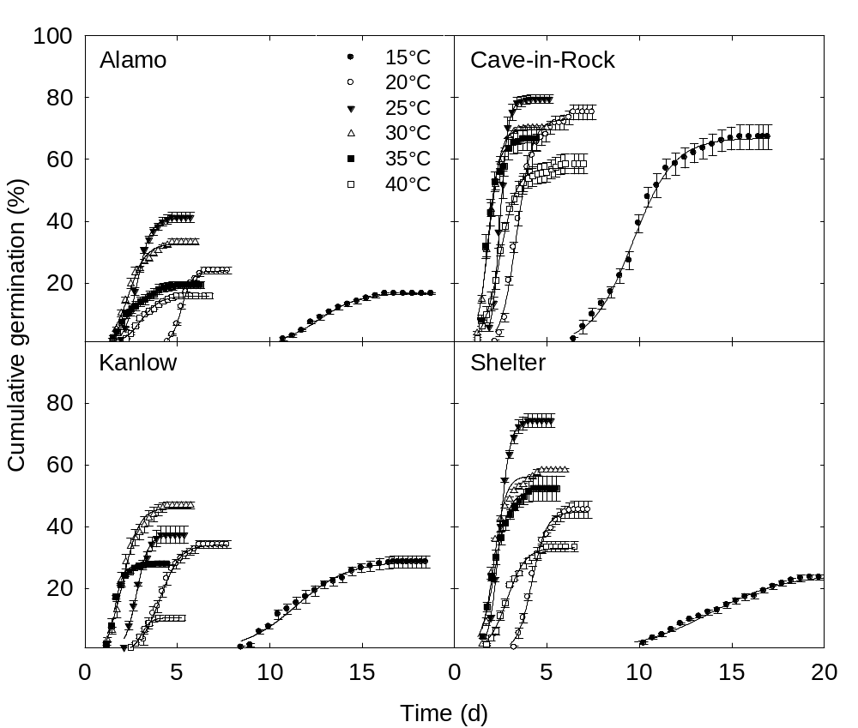

Fig. 2.

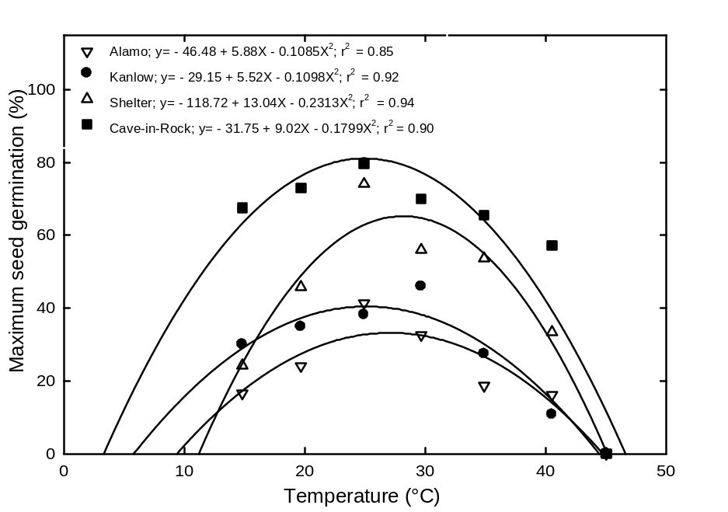

Fig. 3.

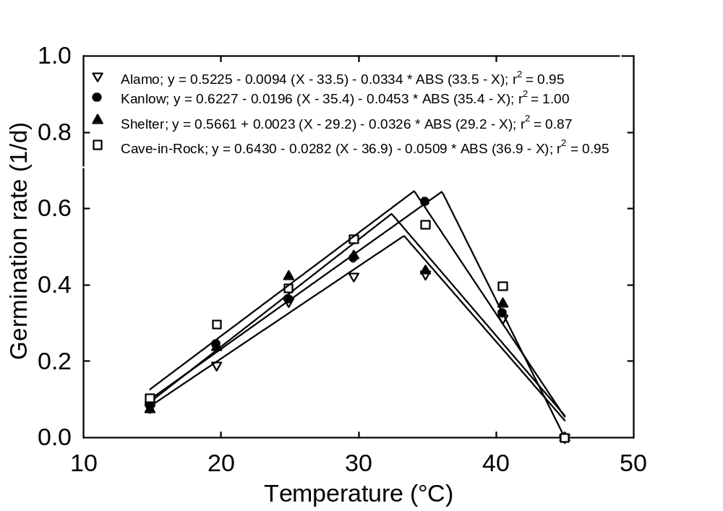
Fig. 4.



